**ECE 212: Sprint Review, Retrospective & Planning report for team _04_ (name)**

(team members listed here), (read the instructions about content of this report first)

# **Sprint Review**

## Previous Sprint Goal

Create a prototype watch that displays time on a 12 hour clock system, as well as notify the user when it is time to wash their hands by using a buzzer for the alert.

## Sprint Backlog Status

(fill in the following table with backlog items that were done and those that were not)

|  |  |
| --- | --- |
| **Sprint Backlog items DONE** (numbered list) | 1. *Program RTC ,* 2. *Program 12 hour clock display (functions without RTC)* 3. *Order Components to build circuit* 4. *Design the 3D model of the watch casing to be printed* |

|  |  |  |
| --- | --- | --- |
| **Sprint Backlog items NOT DONE** | **Reason for NOT DONE** | **Keep in backlog (Y/N); why?** |
| 1. *Building prototype* | 1. *components have not arrived* | 1. *Yes; This is needed in order to test code functionality* |
| *4. Creating RTC 12 hour clock* | *5. did not realize that the RTC uses the 24 hour function automatically* | *4. Yes, will be moved to Sprint 2 as the 24 hour clock function was originally set for sprint 2* |

## Full Product Backlog Pruning

From the Full backlog view, we have finished Most items in sprint 1, Creating the code for the RTC 24 hour clock

and creating the 12 hour code for the Arduino to function without the RTC,which can Realize the time display function of the watch. Due to express delivery failure, we cannot build the full circuit and can not do the test of hardware. This is exactly what we need to continue to do for the next sprint 2. In addition, In the sprint 2 we will focus on the Notification System Approach, timer function and Wire up prototype on breadboard.

In order to better realize the needs of users,we add two items in the next sprint. One is a new module of RTC(real time clock), which benefit is that RTC not only can autofix the time from the computer to achieve the function of real time, but also it does not be affected by power supply. If we do not use RTC, when power is cut off from the computer, the time will set it to 0. Another one found a sensor which for detecting handwashing, which can assist watch start to timing.

Full product backlog:

* Determine which sensor to use for detecting handwashing
  + Make sure that we can read a signal from the sensor
  + Figure out what kind of data each sensor will give.
  + Figure out if we can detect handwashing vs moving hands in normal life.
  + Figure out if we can detect being near a sink (BLE beacon...?)
  + Find costs of different sensor options
  + What sensors can we get ordered in time?
  + What sensors are too complicated to implement in our time frame?
* Wire up prototype on breadboard
  + Get all parts in mail
  + Place parts on a breadboard or mounting board.
  + Test part individually
  + Connect all parts to Nano in one circuit
  + Let the team know that we are ready to start testing code.
* Timer function
  + Look into use buttons to reset timer's "time"
  + Why a timer vs an RTC module
  + Determine how to count for 20 seconds with hardware timer
  + Figure out how to reset timer for next hand wash
  + Make a timer function to let the main program know when the time is up.
* RTC function
  + Look into use buttons to reset timer's "time"
  + Why a timer vs an RTC module
  + Determine how to count for 20 seconds with hardware timer
  + Figure out how to reset timer for next hand wash
  + Make a timer function to let the main program know when the time is up.
* Program LCD screen Display
* program /Add bluetooth or the cloud to a device to collect the data

## Notable technical accomplishments

* Create the code for the RTC 24 hour clock
* Create the 12 hour code for the Arduino to function without the RTC

## Technical and other difficulties

When Garth went shopping for the Uxcell a14121900ux0117 Cylinder Shaped Crystal Oscillators on Amazon, it was going to arrive between September 14th to October 5th which was past our project deadline. Therefore, I found the same oscillator on Newegg website and it will arrive on July 23rd instead. Also the Teensy 3.1 microcontroller has been discontinued, so we went with the Arduino Nano microcontroller instead. Making sure that you read the specifications of each item so there is no mistake and reduce the wait time on delivery.

One of the technical difficulties while working on the project was programming the 12 hour clock. Upon realizing that the RTC would be displaying the time on the LCD, Jana began to write the code for the 12 hour clock to function without the use of the RTC. Another issue that arose while doing this was trying to find the correct libraries to use.

When we started to prepare the 24-hour clock demo code, zheng found that if the power supply of the microcontroller was cut off, the time would be reset to 0, this discovery caused us difficulties. After research and investigation, he proposed to use RTC (real time clock) to solve this problem and realize the time proofing function

### (optional) Technical items that could be improved and suggested improvements

* + Find a suitable sensor to help us timing
  + Using RTC to realize clock demo function
  + Use more communication methods such as google hangout instead of texting for efficient communication

## New Skills

Team member #1 : Jana

* I learned a bit more about programming in the Arduino IDE while programming the code for the 12 hour clock to work without the need of an RTC. I also learned how different components have different functions based on who they are programmed, especially for the microcontroller we will be using. I learned how to communicate with my team better.

Team member #2 : Garth

* I have learned that Trello is a collaboration tool which is used to organize projects, it helps in getting a clear idea about what's being worked on, who is working on it and where something in a process, using this we can effectively manage a project. Also, I have learned that the Arduino Nano can be powered via 6-20V unregulated external power supply or 5V regulated power supply externally. It can be used in robotics, embedded systems and electronic projects because of its small size and flexibility. Being able to communicate effectively with my teammates, helps in achieving the goals of our project.

Team member #3: Zhang

* First, I learned the knowledge of the new circuit hardware module RTC, how to connect it to the circuit and use it to realize the function of real-time clock demonstration. Second, I learned some programming skills, how to find the library more efficiently, and use the library helps me quickly write code.Finally, I learned how to communicate more effectively with everyone, take the initiative to express my views to everyone, solicit opinions, and actively communicate with everyone to solve the problem.

Team member #4: Gabrielle

# **Sprint Retrospective**

First we determined the goals of every sprint. According to different sprint situations, we discussed together what tasks need to be done and when they need to be completed. Put the tasks we need to do in the backlog. Then we start to create a gantt chart and Complete trello board deadline according to the Gantt table deadline. In addition, we assigned the tasks to every teammate on the trello board according to what everyone is good at. Everyone completes tasks according to their own situation, and constantly communicates with everyone, and constantly checks and updates trello's tasks.

## Teamwork and planning - things that went well

* communicating with each other
* good use of trello board
* Partial goals achieved and plans improved
* Material budget is still under control

## Teamwork and planning - things that could be improved and suggested improvements

* Delegation of tasks should be clearer
* Set deadlines to give time to make revisions before task is due

## Trello

(describe how you will utilize Trello better. One paragraph, as needed)

* We will utilize Trello by using labels and splitting up tasks. This will provide some structure and clarity for the subtasks that need to be done and under which category they fall under in terms of task grouping. In addition to this the tasks would be broken down to smaller tasks and assign people to said tasks rather than having multiple people assigned to a single task. This will improve efficiency and the work quality of the group.

## Trello Screenshot

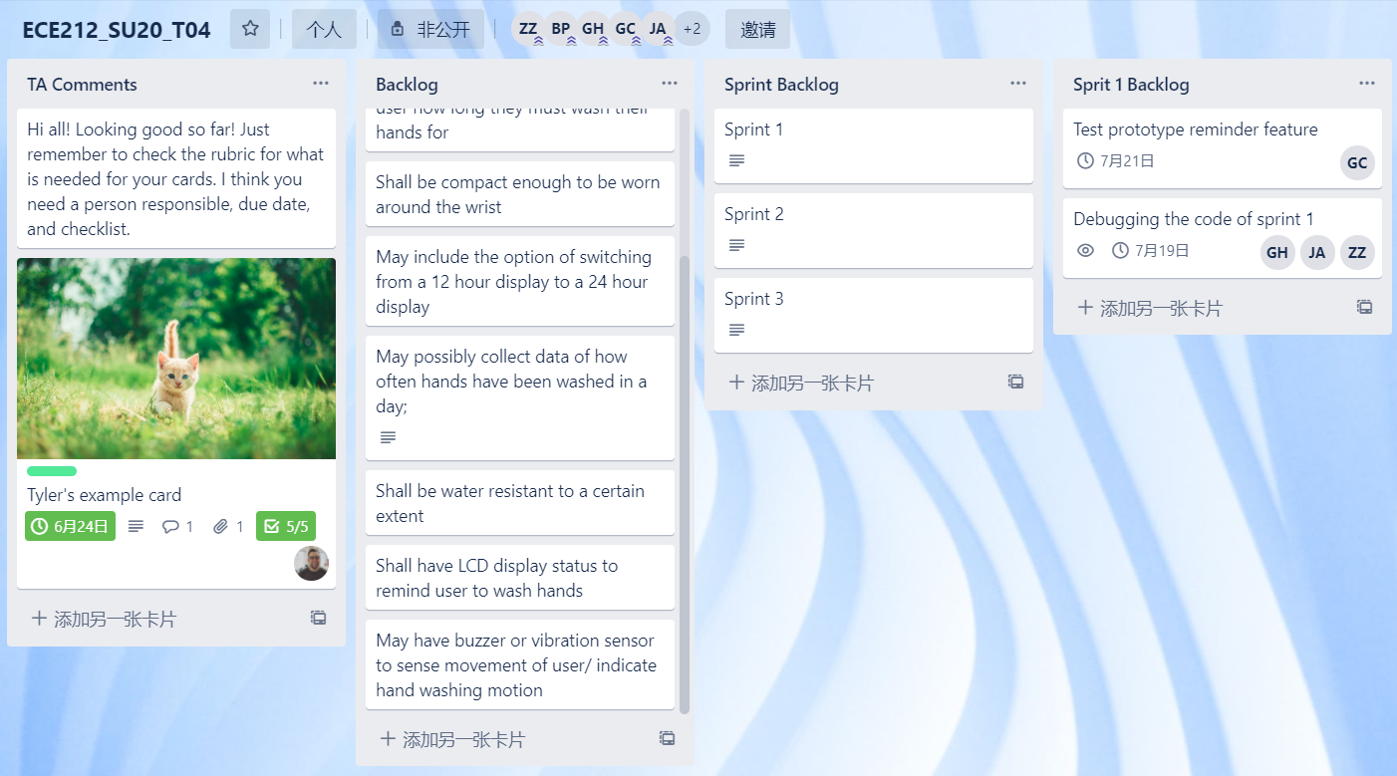

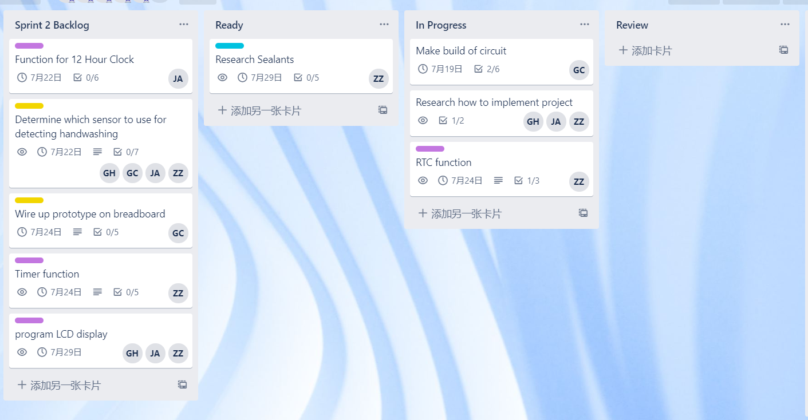

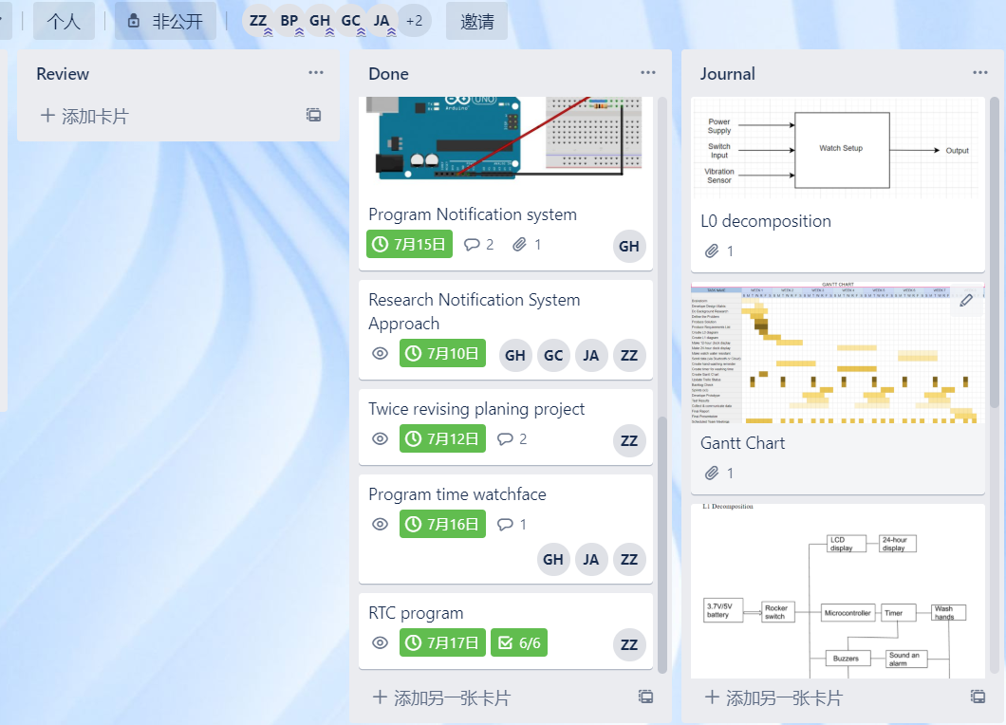

Overall, we would give ourselves a score of **_4/5_** for how well this sprint went.

# **Next Sprint Planning**

## Overall project plan

Our plan is to create a basic watch with smart features that will help upkeep good hygiene techniques as well as send other reminders to the user.

### New Gantt Chart

(put updated Gantt chart here; if you are using Google Sheets to construct it, then make it visible and add a link to it)

### Overall Plan Changes

There have been some changes made to our overall sprint plan for this upcoming sprint plan. Originally we were going to work on the 24 hour clock for this sprint but we realized that the RTC functions with the 24 hour display already. Therefore, we changed the sprint plan to work on the 12 hour display for the RTC specifically. Other than that, the sprint plan remains the same. We will be working on the hand washing timer and reminder for the watch as well as continue working on the construction of the watch.

### Requirements

(give an updated list of your product requirements; most of it should be copied from your proposal or previous sprint; underline changes; **use “shall, should, will” to describe requirements)**

* Shall set time to remind user to wash hands
* shall have a clock function that displays the time in a 12/24 hour format
* shall have a timer to indicate how long the user should wash their hands for
* shall be compact enough to be worn as watch
* may include the option of switching from a 12 hour format to a 24 hour display
* may collect data of how often hands have been washed in a day
* shall be water resistant to a certain extent
* may have a buzzer or a vibration sensor to sense movement of the user/ indicate hand washing motion

### Functional decomposition

As of now there are no changes being made to the L0 and L1 decomposition.

## Next Sprint Details

### Next Sprint Goal

(state your sprint goal)

* Build circuit (mount components together)
* Reminder + notification system
* 12 hour clock capabilities for the RTC

### Priorities & Responsibilities

Our highest priority is to continue working on the code for the watch functions as well as creating the prototype for the watch since there have been some delays in shipping, something that is beyond our control. Zhang will work on the reminder function, Jana will continue working on the 12 hour function of the clock to work with the RTC, and Garth will continue working on building the prototype.

### Test Plans

We will test the functionality of the code in accordance with the circuit that will be built. This will be done in order to see if the code works or not as well as the changes needed to be made to the code based on the setup of the microcontroller and the components connected to the board.

### New Trello Board



Our team *T04* met with our Scrum Master *Tyler Hull* on *17/7/2020*. We discussed Sprint Planning. All team members have read this report and agree that it accurately describes our discussion.